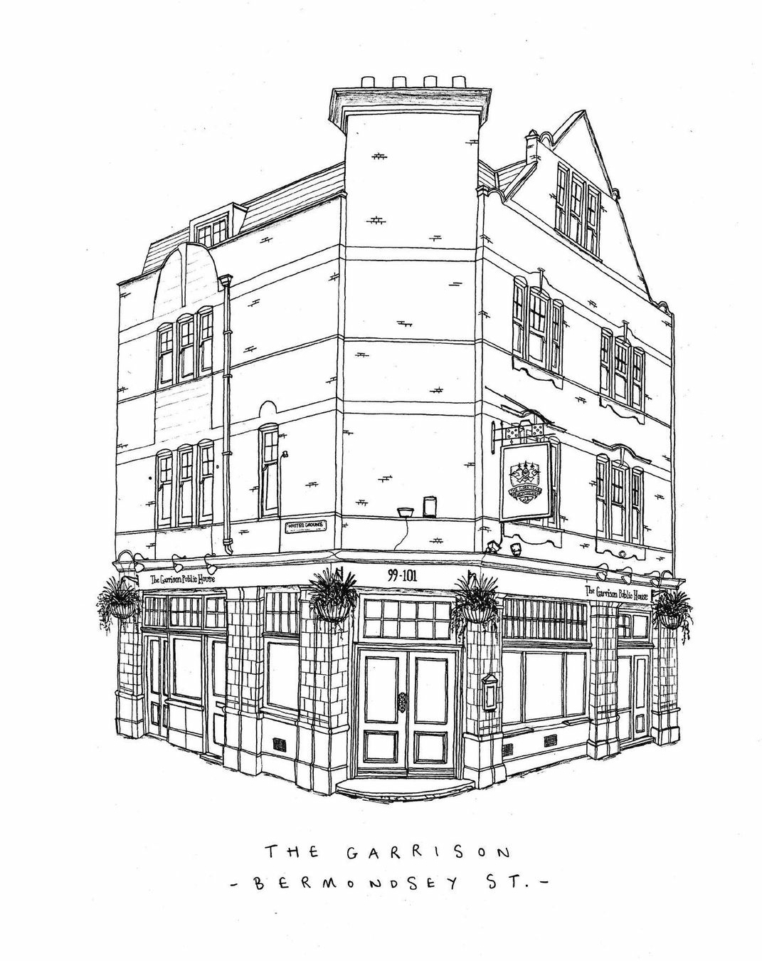
Rosemary Focaccia, Arbequina Olive 4.5
Nocellara de Belice Olives 4

Beetroot Tofu Crisp 9
whipped tofu, tapioca crisp, beetroot

Crown Prince Squash Soup 10
black garlic, pumpkin seed, nutmeg

Queen Scallop 12
whiskey bacon foam, sea vegetables, crispy seaweed

Beef Tartare 12
confit egg yolk, cornichons, capers, beef fat croute

Mosaic of Burt Leek 18
artichoke puree, artichoke crisp, cavolo nero, black garlic

St. Ives Turbot 26
sea aster, brown shrimp beurre blanc, turbot farce

Venison Loin 22
pomme fondant, beetroot, game sauce

Flat Iron Steak 25
pomme fondant, tropea onion, green peppercorn sauce

Beef Shortrib 26
maitake mushroom, veal jus, shoestring fries

Confit Hispi Cabbage, Miso, Chicken Skin 10.5
Charred Tenderstem Broccoli, Mustard, Toasted Almonds 6.5
Honey Glazed Heritage Beetroot, Walnut, Mint 5.5
Confit Pink Fir Potatoes, Capers 5.5
House Chips, Black Garlic, Parmesan 5.5

Puddings

Dark Chocolate Crémeux 8.5
blood orange sorbet , coconut, white chocolate

Rhubarb & Ginger 8.5
cheesecake espuma, rhubarb compote, ginger crumble

Sticky Toffee Pudding 8.5
vanilla, caramel

Banoffee Pie 8.5
praline, banana ganache, white chocolate crème

Neals Yard Cornish Yarg 14
pasteurised cow’s milk, onion chutney, oat biscuit

Pudding Wines
Tawny Port 6.5 55
Ruby Port 6.5 55
Pedro Ximenez 8 45

Loose Leaf & Naturally Decaffeinated Teas

Fresh Mint 4
Lemon & Rosemary 4
Goji berry & Cranberry 4
Elderflower & Ginger 4

