

Soft Drinks

All soft drinks are made in house, with minimal sugar   
& fresh fruits

Seasonal Iced Tea 5.5

Still lemonade 5

Hot drinks

**Coffee**

Gentlemen’s Barista’s Stovepipe, a blend of 50/50 Mexican & Brazilian

*Coffee selection 4*

**Loose Leaf & Decaffeinated Tea**

Breakfast Cuppa 4

Earl Grey Blue Flower 4

Fresh Mint 4

Lemon & Rosemary 4

Goji Berry & Cranberry 4

Elderflower & Ginger 4

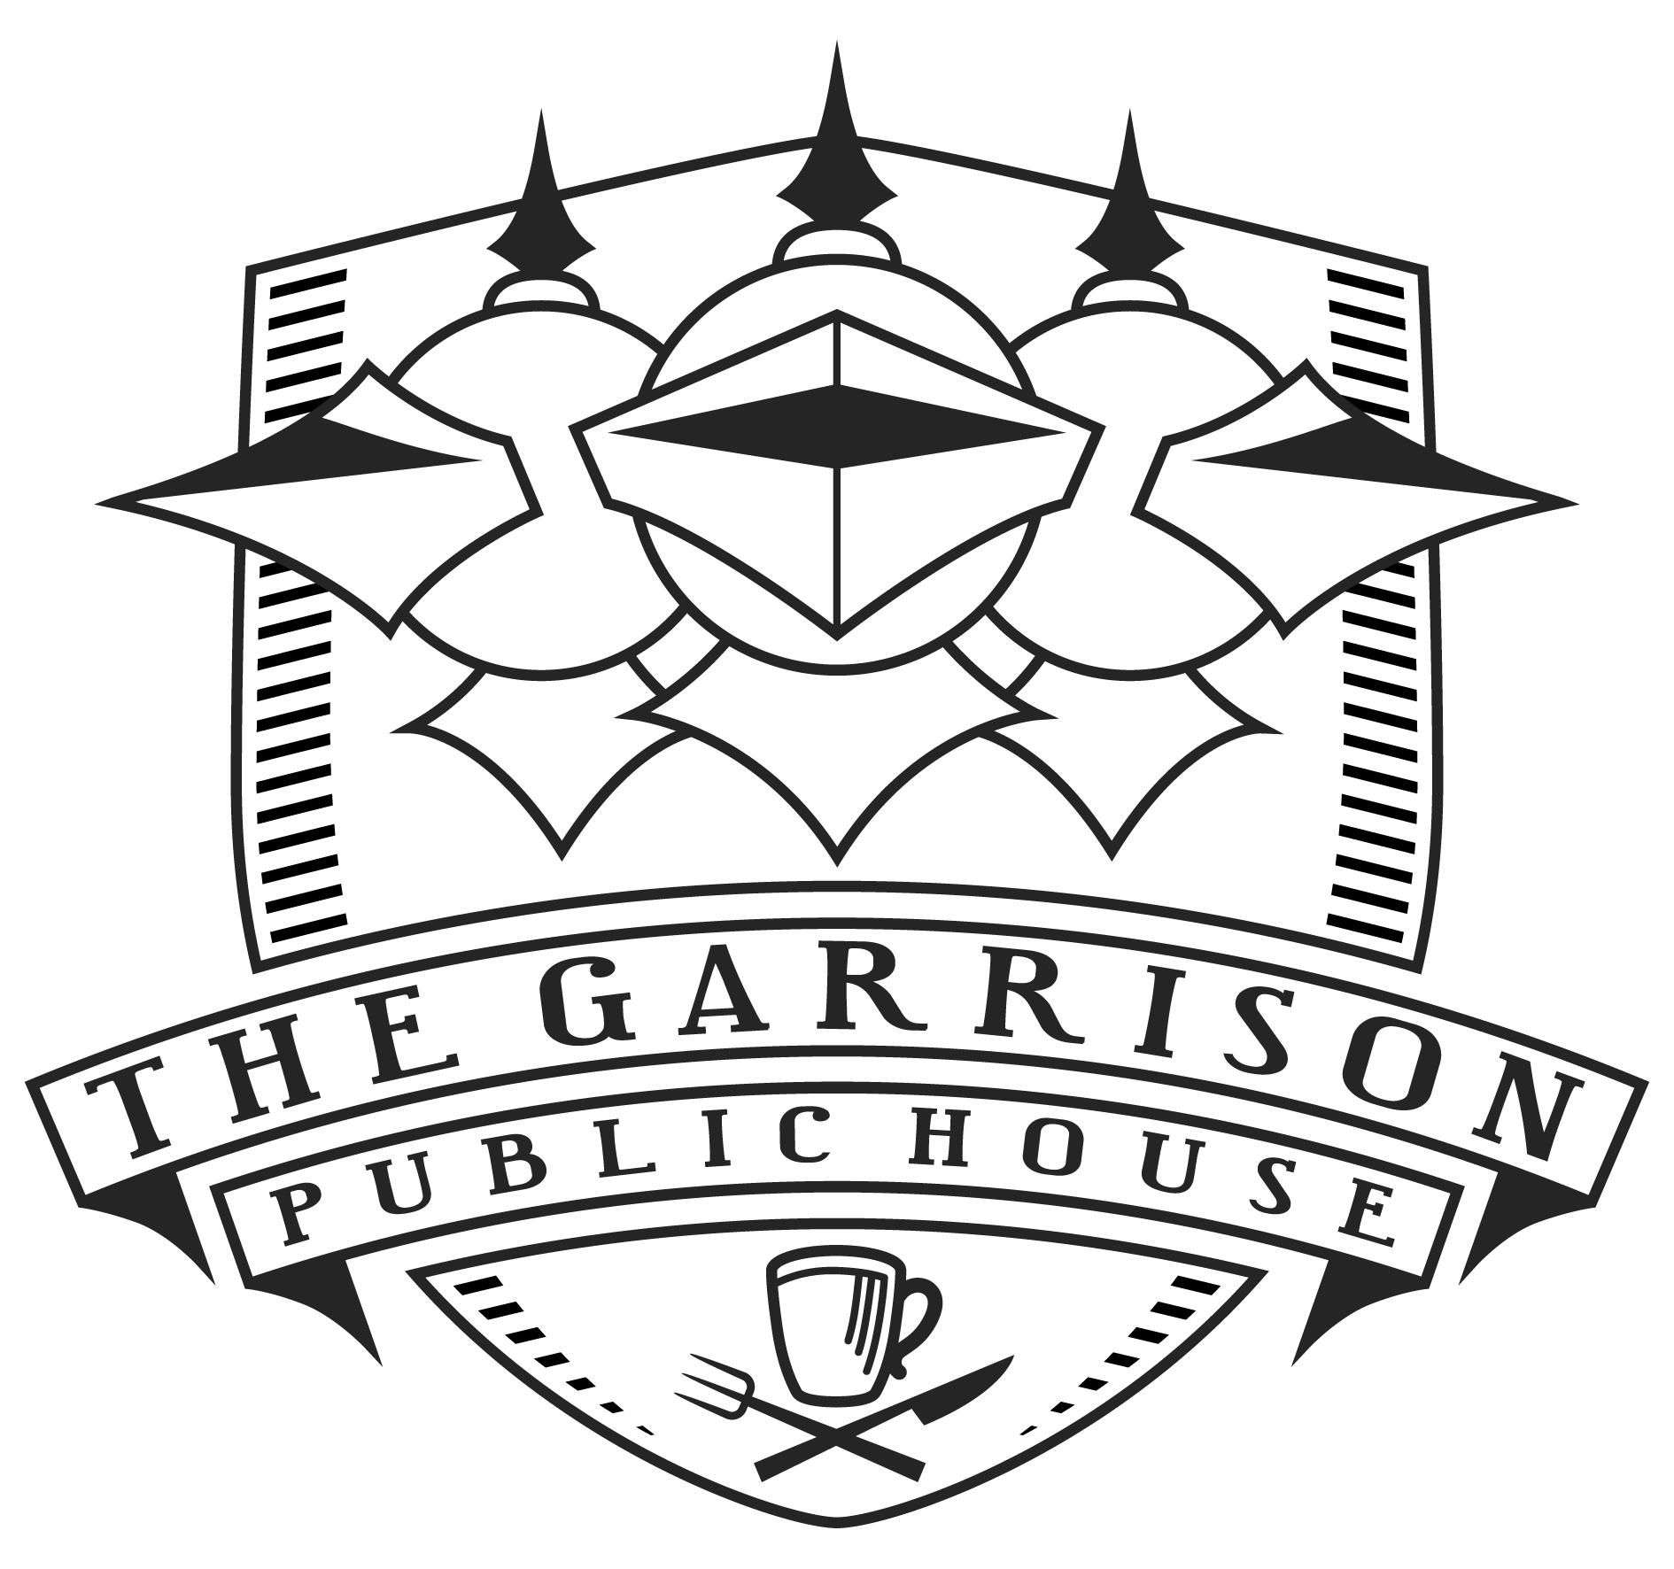

The Garrison

Drinks

A Bermondsey institution since 2003, The Garrison has grown up with the surrounding neighbourhood, but always with an eye to its original intention: to serve quality local food & drink & do it with a smile.



Gin, Continued

Little Bird – Peckham Rye –– 10.50

Cotswold Gin – Warwickshire –– 10.30

Portobello Road – London -- 10

Hendricks – Scotland –– 10.30

Roundhouse Gin – Birmingham –– 10.50

Beefeater – London – 8.9

Lyres – No alcohol –– 8

Fevertree tonic 3

We also have a small selection of other world gins, ask your bartender for more advice

*All spirits are served as a 50ml measure, if you would like a 25ml measure please ask the member of staff upon ordering.*

*Please let us know if you have an allergy or intolerances. We are happy to provide you with any information you may need.*

*A discretionary 12.5% service charge will be added to your bill all of which goes to our staff. This need not be paid if you feel service was unsatisfactory.*



Cocktails

Our drinks list is continuously changing, focussing on sustainability & local produce our menu is created with food pairings & seasonality in mind.

Garrison Spritz – 10

london dry gin, black raspberry, elderflower, citrus prosecco

Passion Fruit Fizz - 12

vanilla vodka, passion fruit, whites, champagne

Cinder - 11

mezcal, port, lime, ginger

Double Fill – 10.5

rye whisky, citrus, pomegranate

Spicy Blueberry Margarita - 10

blanco tequila, confit chilli

Cherry Blossom Spritz (alcohol free) - 8

rosehip, strawberry, lemonade

Classic cocktails are available upon request.

Gin

Our gin menu is a walkthrough Britain in both time & location, offering samples from some of the best distilleries. Pairing them with featured tonic water.

Hayman’s Old Tom – Camden –– 9.5

Tanqueray Nº10 – London -- 10

Plymouth Gin – Plymouth –– 10.5

Tarquin’s – Cornwall – 10.50

Martin Millers – London -- 10

Gin Mare – Spain – 10.30

Monkey 47 – Germany -- 12

Fevertree tonic 3

We also have a small selection of other world gins, ask your bartender for more advice.

*All spirits are served as a 50ml measure, if you would like a 25ml measure please ask the member of staff upon ordering.*



White Wine & Rose

Vialleto Pinot Grigio DOC - Italy 7.35 29

Vinho Verde Quinta da Lixa - Portugal 7.55 30.5

Ca’Di Mezzo Gavi – Italy 8.75 35.25

Fratelli Felix, Campania Bianco - Italy 10 38

Babich Headwaters, Sauvignon Blanc – New Zealand 10.1 41.5

Angelo, Catarratto, - Sicily 26

Vinalthau Viognier – France 36.75

Sonrio Cuando Llueve, Albarino – Spain 39

Bonny Doon le Cigare Blanc, California-USA 42

Sancere Prestige, Domaine de la Gemiere – France 44.25

Chablis Domaine Brocard – France 45

Mure Riesling – France 47.5

Peregrine Organic Pinot Gris, Central Ortago - NZ 60

Joseph Drouhin, Chardonnay, Burgundy–France 78

Trimbach Riesling 2013, Alsace-France 120

Martin Codax Orange Wine, Rias Baixas-Spain 42

Bodegas Verum Las Tinadas Organic Airen, La Mancha-Spain 52

Rose Cotes de Provence – France 11.2 46

Ken Forrester Petit Rose – South Africa 10 38

Whisky

**Scottish**

Chivas 18yr 16.3

Auchentoshan 12yr 15.5

Laphroiag 10yr 14.5

Glenmorangie 10yr 12.5

Lagavulin 20.5

**Otherworld**

Bulleit Bourbon 9.5

Rittenhouse Rye 10.5

Makers Mark 11.5

Johnny Walker Black Label 14.7

Jamesons 10.5

*All spirits are served as a 50ml measure, if you would like a 25ml measure please ask the member of staff upon ordering.*



Red Wine

Raccalanna Montepulciano D’Auruzzo -Italy 7.1 28

Bodega Norton Porteno, Malbec – Argentina 7.7 31

Te Henga Pinot Noir – New Zealand 9.55 39.25

Conde Valdemar Rioja Reserva - Spain 10.7 44

Jealousy, Pinot Noir – France 32.5

Cloof Inkspot, Shiraz – South Africa 34.25

Château Bourdicotte, Bordeaux – France 37

Gentle Folk Vin de Sofa – South Africa 38

Valpolicella Black Label, Pasqua, Vento – Italy 40.5

Domaine Tournon Shiraz – Australia 41

La Conquista, Tempranillo – Australia 42

Salt & Stone, Zinfandel – USA 44.5

The Chocolate Block, Syrah South Africa 50

Ken Forrester, Syrah, Stellenbosch-South Africa 115

Joseph Drouhin Gevrey-Chambertin, Burgundy-France 120

Beers & Cider

**Draught**

Estrella 3.2 6.3

Guinness 2.7 5.4

Deya Steady Rolling IPA 3.6 7.15

Asahi 3.45 6.85

Camden Hells Lager 3.35 6.70

Brooklyn Brewery No Alochol – 0.4% 5.8



Champagne & Sparkling

**Champagne**

Veuve Cliquot Brut Yellow Label 90.5

**English Sparkling Wine**

Nyetimber Classic Cuvee 12.5 66.5

Nyetimber Blanc de Blancs 81.5

Nyetimber Rose 76.5

Tempio Prosecco DOC – Italy 7.15 35.75

**Pet Nat’s**

Naturally sparkling wine

Negrette, Fronton - France 40

Scirocco ‘Lucie’ Organic, Sicily – Italy 55

Extended Wines

Fine Wine

**White**

Meursault, Chardonnay, Burgundy-France 24 120

Cloudy Bay Sauvignon Blanc - New Zealand 2023 65.5

Carneros Chardonnay, Buena Vista – California 2020 75

**Red**

Julienas Chateau Des Capitans - France 2021 55.5

Chateauneuf-du-pape Le Parvis – France 2021 85.5

Masi Costasera Amarone della Valpolicella – Italy 2018 87.5

Macan Clasico Rioja, Rothschild Vega Sicilia 2019 100.5

Fine wine served at a 125ml measure